Martin Gardner 101
A Tech Talk by Colm Mulcahy

Thurs July 30, 11am, MTV-1950-1-Bodega Bay

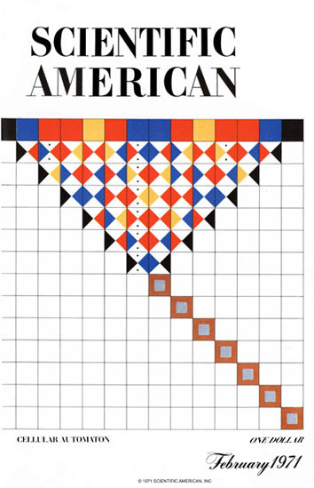 | 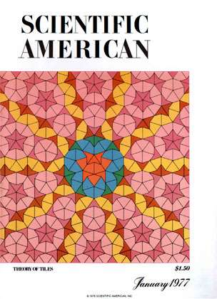 | 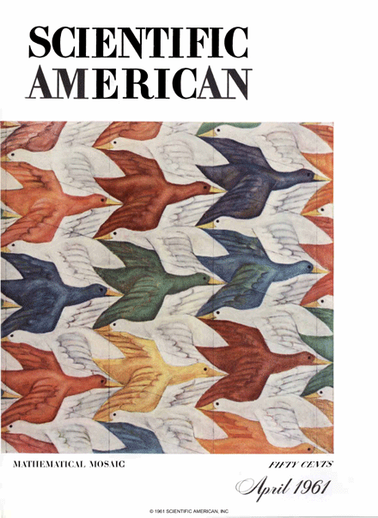

Martin Gardner authored the Mathematical Games column in Scientific American from 1956 to 1981.
He authored 101 books on topics ranging from magic, physics and puzzles
to Alice in Wonderland, skepticism, philosophy and religion.

He's been called The Best Friend Mathematics Ever Had.

Those interview puzzlers (that we don't use anymore) largely came from his books and columns!
Conway's Life, Hexaflexagons, Public Key Cryptography, and Penrose Tilings
were all popularized by Martin Gardner,
and have become a core part of our Silicon Valley culture today.
Conway's Game of Life  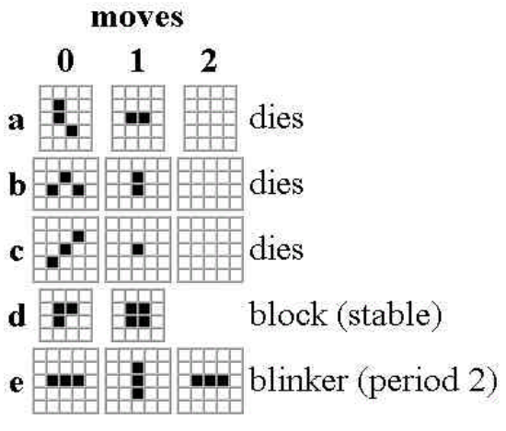  October 1970 |   Martin Gardner  1914 – 2010  (and would be 101 this year) | 

